**University of Hertfordshire  
 School of Computer Science**

**BSc Computer Science**

**Module: mobile computing**

Assignment: Usability Analysis Report

Aoun Muhammad Abbass  
Level 6

2022-23

Contents

# **Introduction:**

This report has been developed to provide a thorough insight into my Mobile Application, called “EzMerch”. EzMerch is an E-Commerce Merchandise-selling platform which focuses on providing a one-stop solution for major YouTuber’s Merchandise i.e., PewDiePie, KSI and MrBeast for all fans out there. I designed this application by the implementation of HTML syntax, external styling via CSS, functionalities’ programs executed via the use of JavaScript, server-side display and connectivity with MySQL back-end database using PHP.

# **About the EzMerch Application:**

As stated earlier, EzMerch was intended to reduce YouTube fans’ headache of having to scour the internet over many websites to just obtain their favorite merchandise, most of which would usually be sold out by the time the fan would find an authentic piece of merchandise. As such, I catalogued my application to have the most sought-after pieces of apparel stocked at one spot so that anyone could just come in and conveniently order within just a few clicks. For background research, I took in inspiration from represent.com/PewDiePie and MrBeastStore.com as some of the most popular youtuber merch stores out there to come up with the design for my application, a few of the initial design sketches that I based my UI on are as follows:

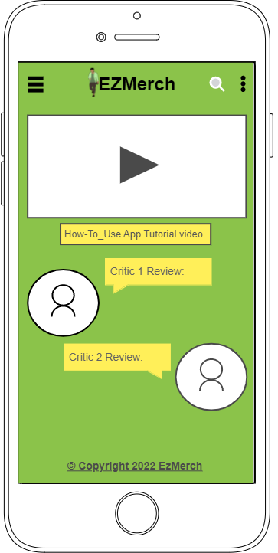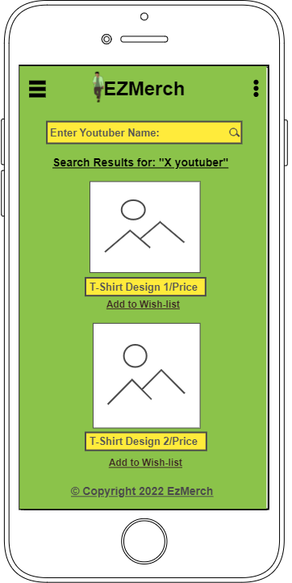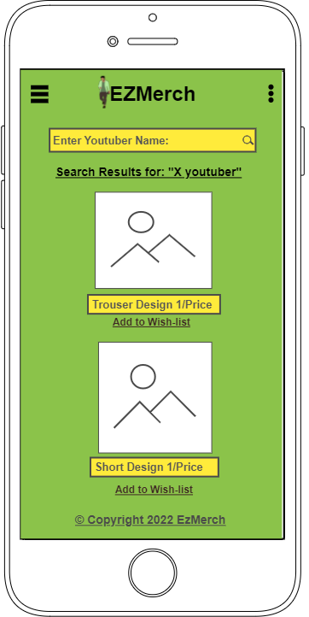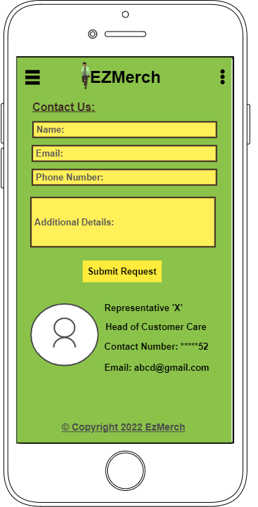

Figure Initial Mockups of Application

# **Design Process:**

As you can see from the mockups, my initial web application included a green colored background, with the logo being centered and navigation on the left. However, I decided after looking at some modern-day e-commerce web application examples that a lighter colored background would be more suitable, hence I used a light-blue color instead, and also placed the EzMerch logo to the top-left with the Hamburger Navigation to the top-right, to give a more sleek look that would make the navbar seem more accustomed to what the everyday application designs a user encounters on the daily basis.

When it comes to the Application’s Overall Design, my main inspiration was focusing on a modern-day online clothing store by the name of Rastah. Official, website link: <https://pk.rastah.co/> which is one of the biggest online shopping hubs in Pakistan. Its elegance, attractive and easy to use UI were the main features that caught my attention. My Homepage’s design in comparison to Rastah is as follows:

Figure Homepage Comparison

I used a Stock-Video with some teens wearing trendy merchandise as the main catch on my Homepage, as it would prove to more interesting for my potential customers that are mostly teens who are fans of YouTubers. Moreover, I adapted the critics review section as well underneath to show authenticity of products being sold. One thing I could’ve improved upon in my homepage is that by adding a Call-to-Action Button, similar to the one present on the Rastah App’s page, underneath my video and below the critics’ reviews section, I could’ve further made it easier for the user to navigate to relevant products page to access their desired merchandise directly without having to go through the navbar and then search for their relevant products tab.

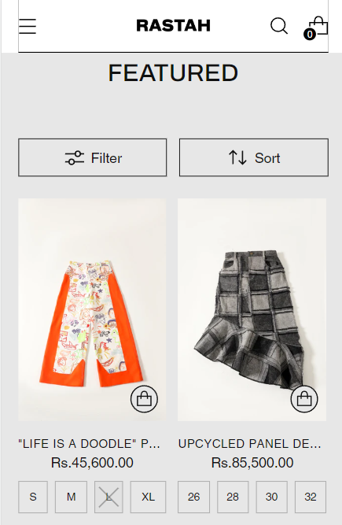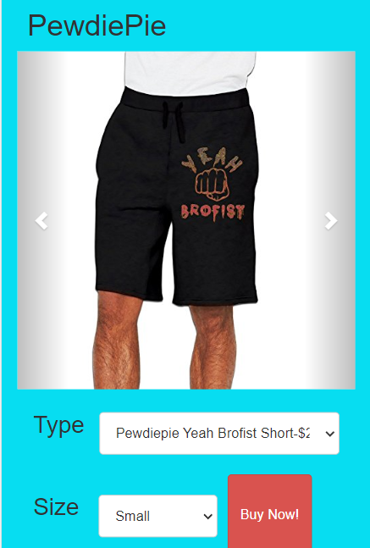

Figure Products Page Comparison

As the main focus of my web applications UI is on being as simple and easy to use as possible, so that even a child Youtuber-fan can easily navigate and get their desired merchandise with as few clicks as possible, I set it up so that only some of the most desired articles are catalogued, vertically, with full-width view of each clothing article as well as simple drop-downs to select Product Type and Size underneath, in comparison, to a bit more complex layout of Rastah Products, which are of wider variety range and arrange horizontally and have much more jam-packed information and smaller buttons for size underneath. Still, the Rastah Products page has a few cool features that I could have implemented such as adding a Product Filter and Sort List on top of my Products’ Pages could have made it feasible for users to just sort through the product range and end up at their desired merchandise display specifically instead if having to scroll through all the product range instead. Also, even though I added Big Red “Buy Now Buttons’ to again bolster the aspect of even kids finding it easy to buy products, like Rastah’s, having Add to Shopping Cart List Buttons with each product would’ve made selecting a higher number of products possible, as with my design, a user could only select a single product at a time to purchase. Even though, YouTube merchandise is sold-out so fast due to high demand, that mostly 1 or 2 pieces of each product are the maximum that a user has time to buy, having the ability to add even more would make the lucky fan with a larger number of products, able to get more products in one go.

Figure 4 Billing Details Comparison

When it comes to the Billing Page, my web application’s layout is simple and straightforward where the user just enters their necessary personal details such as Name, Email. Billing Address and Area Zip code and the other is easily placed on a Cash-On-Delivery Basis so that the Customer only pays when they are satisfied with the quality and integrity of the product they receive at their doorstep, rather than facing the possibility of being scammed, as many fake websites selling YouTuber merch do consistently, by paying first via Credit/Debit Card, only to receive a damaged/incorrect product later. However, if I had again added an Add-to-Cart feature, like the one Rastah has, the overhead display of a summary of details of product(s) selected and, most importantly, total cost of all products + Shipping Cost + Tax(if exported to another country outside Pakistan) would give peace of mind to the customer that they have all prior knowledge of all costs applicable before making their purchase and hence, lead to improved trust in the web application at the user-end

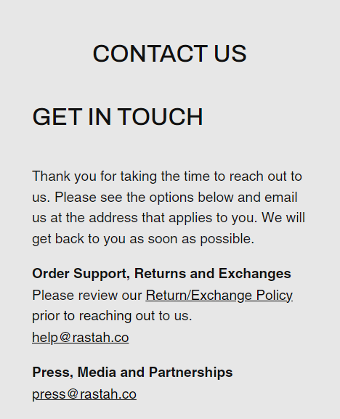

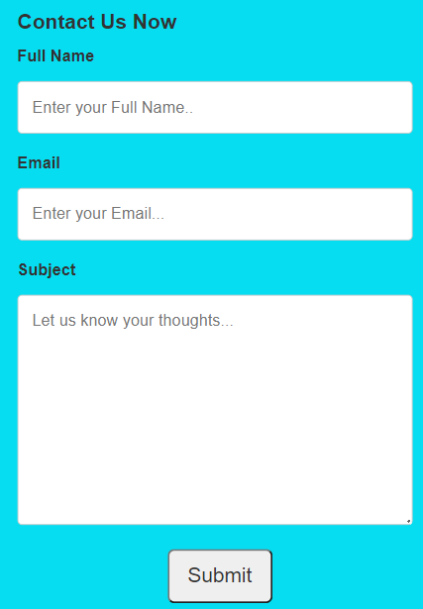  
It was necessary to provide a page where a user with issues related to Application functionality, billing details and general queries as well as valuable feedback could contact me directly. As such, keeping a simple yet direct method of communication in mind, I designed a pretty straightforward set of input fields where the user could directly submit feedback/complaint rater than have to access their emails, go through the login process of their emails every time and then send me their feedback externally, like the way Rastah has done with providing just an email link instead for feedback which would lead to more hassle than its worth. However, a feature I can appreciate and would have benefited from is by attaching a well-documented, thorough Return/Exchange Policy which would have laid out the exact terms and conditions under which an Item, Once bought, could be returned or exchanged for another, which would allow the user to have preemptive knowledge of return/exchange technicalities before opting for sending a request of Return/Exchange.

Figure Contact Us Page Comparison

# **Difficulties Encountered:**

Some of the main difficulties I encountered during development of the web application and their solutions are listed as follows:

1. **UI Design and Structure:**

As you can see by the above example of Rastah. Official and also considering many of popular merchandise/clothing applications I researched into were complex and involved lots of JavaScript functionality, due to lack of time and sickness of health as well as to keep my application as Simple and Easy-to-Use as possible, with less programming involved to achieve the required functionality, I used only simple resources such as w3schools, codeacademy and easy-to-follow YouTube tutorials to design my application.

1. **Adding Php Functionality to large number of Data Input types and storing them in the MySQL Database:**

A major problem for me was the tedious task of implementing appropriate Php functionality to allow for data types such as input fields, drop-down selections for sizes, types of merchandise as well as order and contact details being to be stored into their relevant database tables. This was due to the Php code syntax constantly giving errors and being time consuming and also, a lack of in-depth knowledge of Php in general, due to which I made the task easier by using Buy Now Buttons to directly purchase a single product via linking it to billing details page where only the necessary details were stored in tables and order was completed. Similarly, it was done for Contact us page.

1. **Add-to-Cart Functionality:**

Perhaps the biggest issue I faced was that all the common shopping applications that I researched online had Add-to-Cart functionality, which required a lot of javascript coding and php functionality as well as back-end database support to implement properly. This, given that my time left for submission was low, health status compromised, I wanted to achieve the billing functionality in the most straightforward manner possible which would get the job done regardless. Hence, I sacrificed large numbers and complex codes for a single product linked to billing page, where all data was submitted via post method to relevant database fields in MySQL to complete the order and generate a confirmation message to user that order has been successful.

All in all, when we take at the overall look of the objectives of simple yet straightforward functionality, my web application was clearly able to meet those objectives in a manner that would satisfy the end-user. Although, as stated by the main comparisons before, I would have liked to have added some additional features and functionality to the application, due to being sick in health and having lesser time and mental capacity to focus on the more complex functionalities, I was not able to implement these additional features on time. Still, the end result is promising enough to say the least.